**Django project Version 4 Notes**

Django Database and Creating Models

---------------------------------------------------------------------------------------------

**STEP 1 - Create a second App**

1. In terminal, type the following to create a Notes App
   1. django-admin startapp notes
2. Go to project folder (“smartnotes”) > settings.py
3. Add 2nd app “notes” to INSTALLED_APPS
4. Create a new class in 2nd app folder “notes” > models.py
   1. class Notes(models.Model):
      1. title = models.CharField(max_length=200)
      2. text = models.TextField()
      3. created = models.DateTimeField(auto_now_add=True)

* Class inherits from models.Model (tells Django it’s a model)
* CharField() is a shorter character or text field
* TextField() is a longer text
* Max_length is the maximum length of CharField or TextField
* DateTimeField() is a date field
* auto_now_add=True means the date/time the model was posted will be added saved as a variable in the class

Models in 2nd App “Notes” should look like this

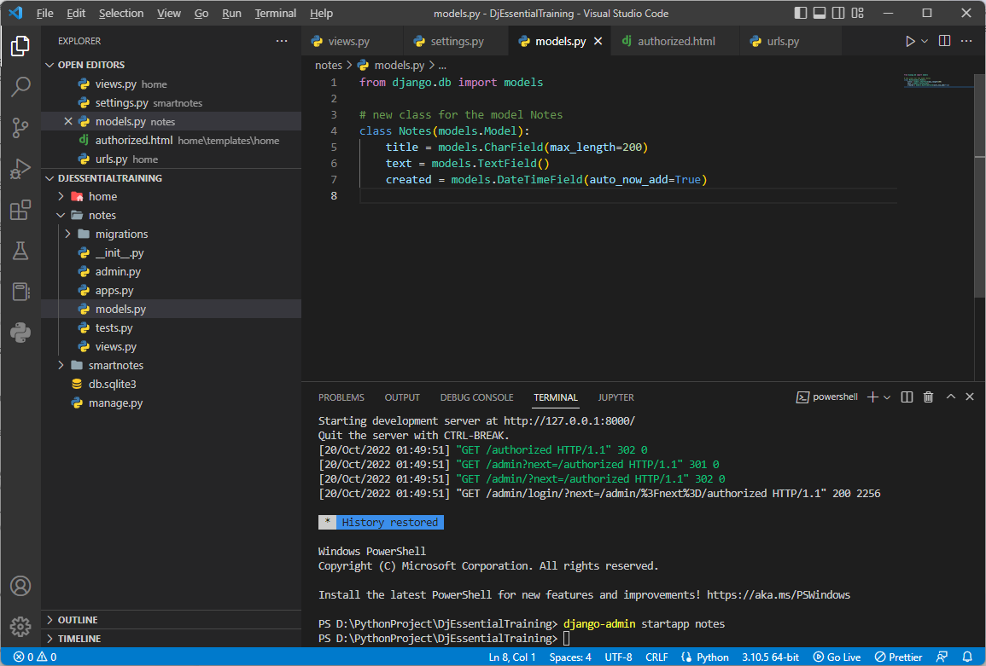

**STEP 2 - Migrate Model to Database**

1. In the terminal, type the following:
   1. python manage.py makemigrations
2. In the terminal type the following:
   1. python manage.py migrate

* Make Migrations
  + Prepare migration files/database files to be pushed/migrated to database
  + Like Push in GitHub
  + Create Django model, prepare it, and organize the structure before it’s sent to the database
* Migrate
  + Pushes/sends models to database
  + Like Commit in GitHub

What your terminal should look like after making migrations and migrating model Notes

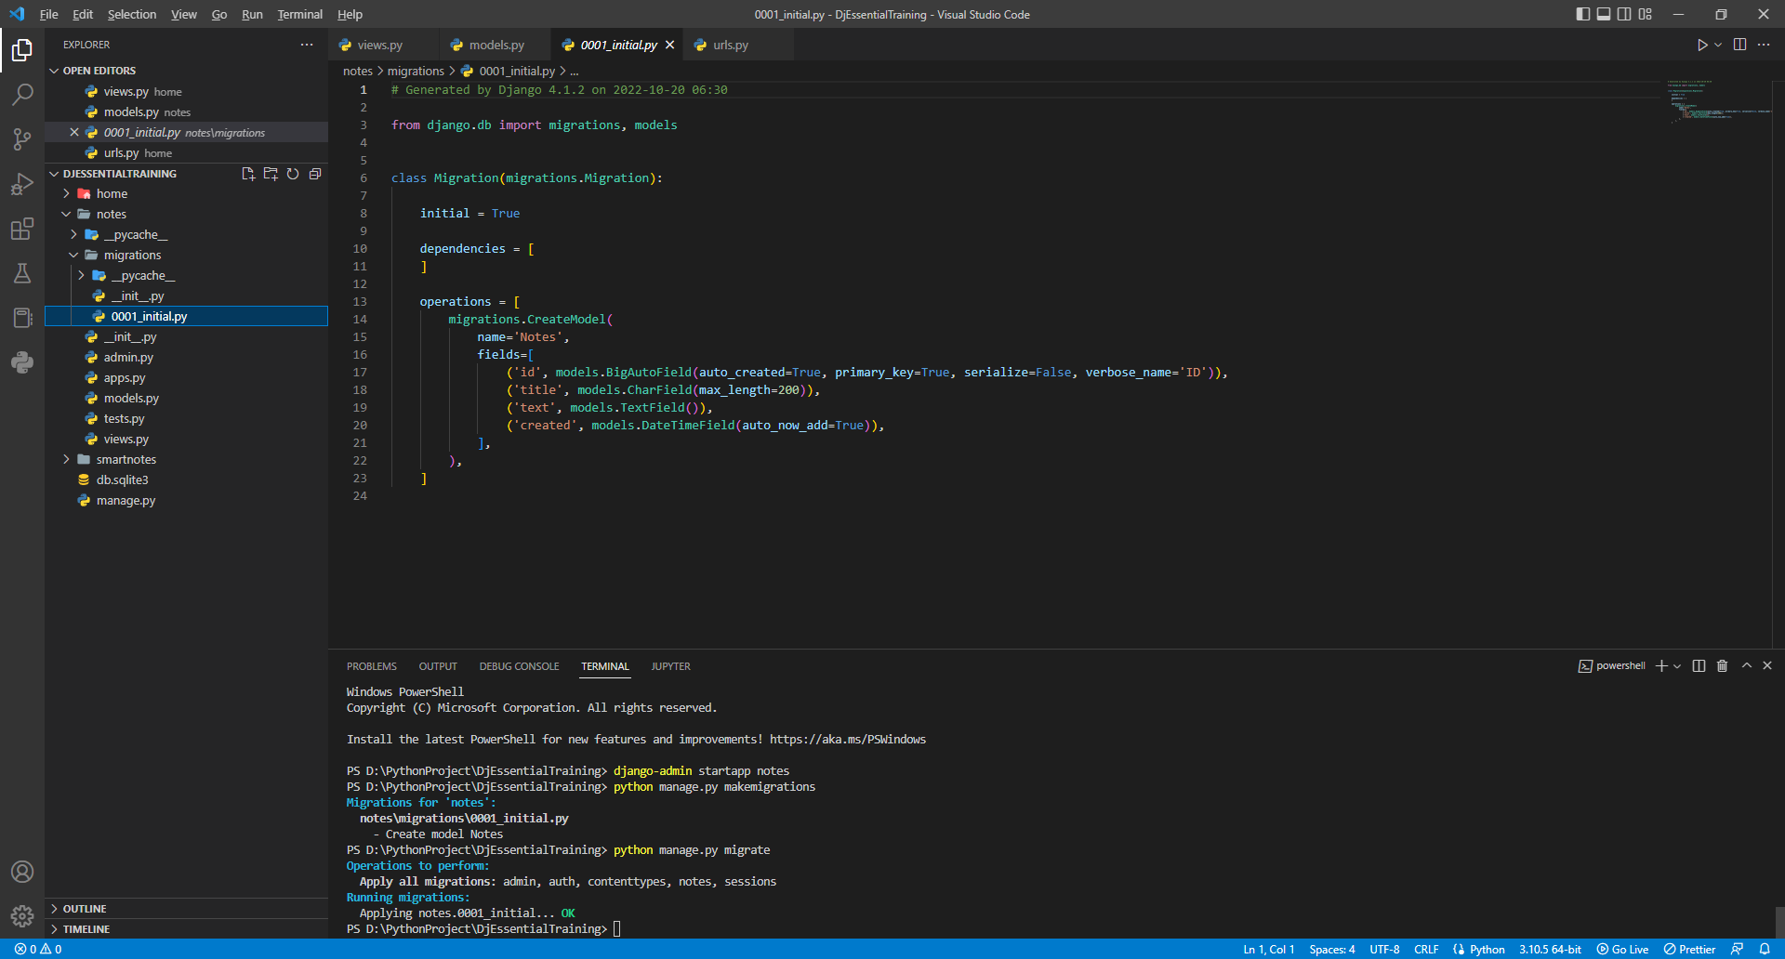

**STEP 4 - Allow Models to Display in Admin Panel**

1. Go to 2nd App “notes” > admin.py
2. Import models
   1. from . import models
3. Create class NotesAdmin
   1. class NotesAdmin(admin.ModelAdmin):
      1. pass

* The class inherits from admin.ModelAdmin
* Pass is a placeholder for future code

1. Register that the imported model is attached to the admin model
   1. admin.site.register(models.Notes, NotesAdmin)

What 2nd App “notes” admin should look like

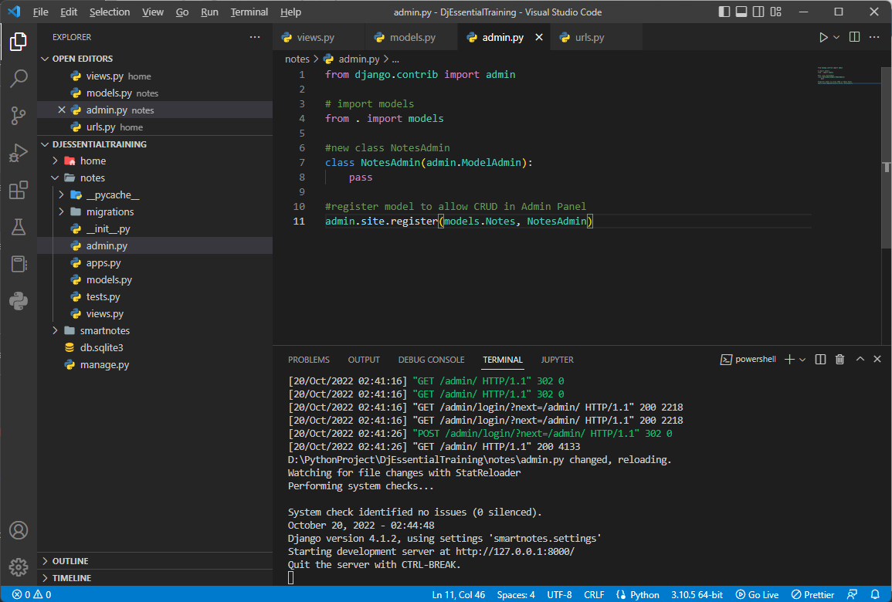

What your Admin Panel should look like afterwards

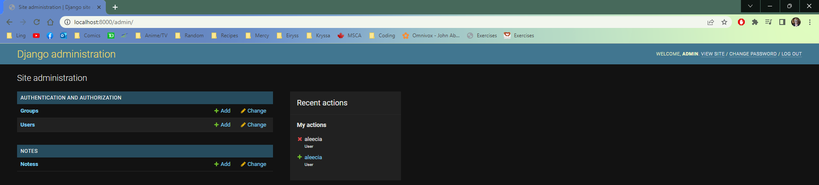

**STEP 5 - Admin Panel with Models**

1. Go to Admin Panel
2. To add a new Note, click Add
   1. Give it a title and text, click SAVE
3. Go to 2nd App “notes” > admin.py
4. Add body to class NotesAdmin() (replace “pass”)
   1. List_display = (‘title’,)

* Allows Notes to be displayed by their titles
* (‘title’,) is a tuple

What the Admin Panel looks like after creating a new Note

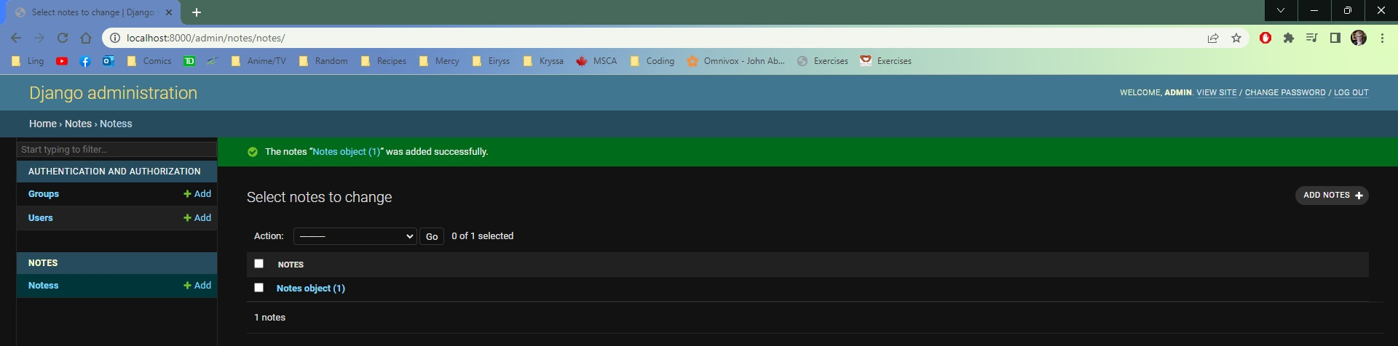

What the Admin Panel should look like after editing the admin file

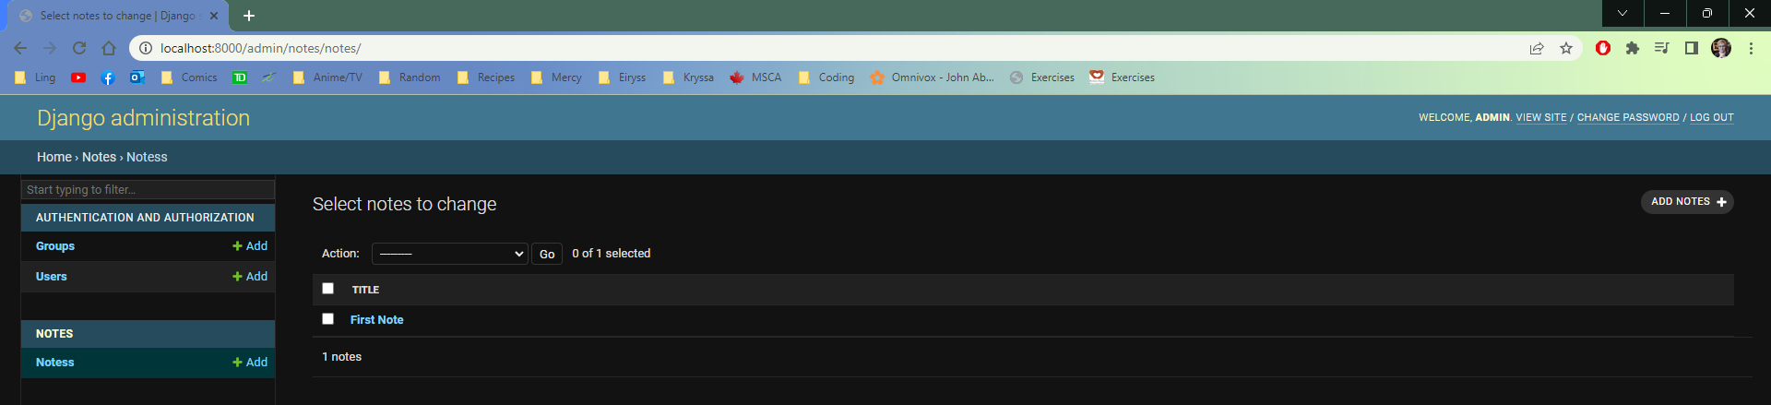

What the 2nd App “notes” admin file should look like

